**AWS Task-1.1**

1.Create a windows Vm machine in AWS and connect with RDP open CMD in windows share the about system info.

RDP interface

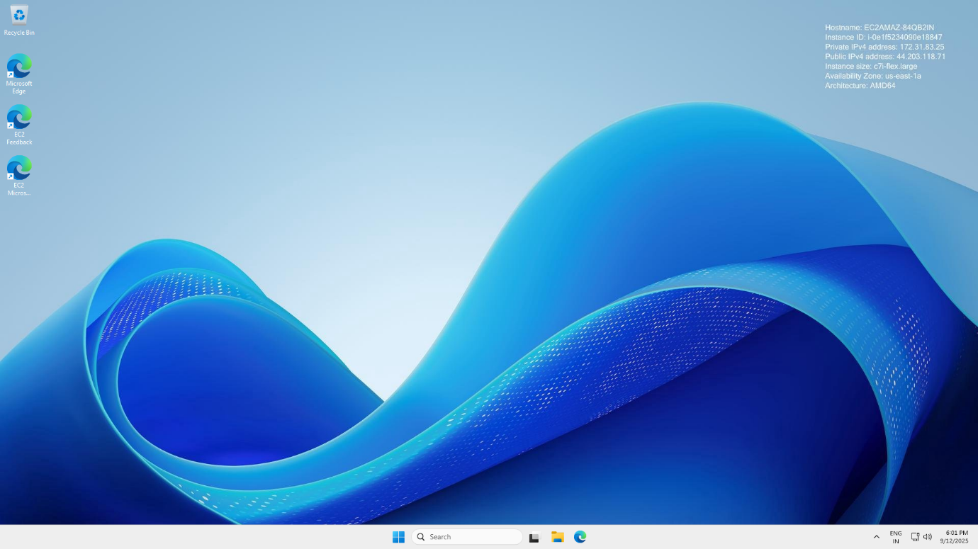

System Info

